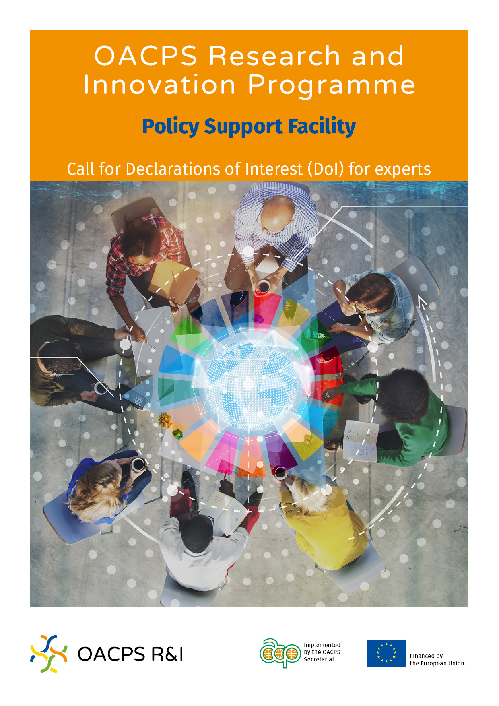

Table of Contents

1. Introduction 3

1.1 Background 3

1.2 The OACPS Research and Innovation Programme 3

1.3 The OACPS R&I Policy Support Facility 3

1.4 Types of PSF services 4

2. The OACPS R&I PSF Call for Declarations of Interest 6

2.1 Objective of this Call for Declarations of Interest 6

2.2 The activities to be carried out by the experts 6

2.3 Submission and registration process 6

3. Assignment of the experts for a PSF service 8

Annex I - The Application Form 9

**JANUARY 2021**

1. Introduction

The present document provides information on the PSF and its services. It also explains how to complete and submit an Declaration of Interest (DoI) for experts. Applicants are strongly encouraged to thoroughly read this document prior to completing the application form.

1.1 Background

In a world characterised by increasingly rapid scientific and technological changes and emerging crises, Research and Innovation (R&I) are, more than ever, recognised as key drivers of sustainable and inclusive development. R&I increase economic convergence and unlock productivity growth, competitiveness and high quality well-paid jobs (EC, 2020[1]; OECD, 2018[2]). They are a tool for analysing the impacts of change and a means for ensuring that any transition leads to an improvement in our well-being.

R&I can address societal challenges, accelerate green transition, create new jobs and businesses, and help poverty reduction. They are instrumental to the implementation of the UN 2030 Agenda for Sustainable Development, the African Union Agenda 2063 ‘The Africa We Want’, ‘The Samoa Pathway’, and other international and regional policy frameworks.

A growing number of African, Caribbean and Pacific (ACP) countries are incorporating R&I in their national development agendas to accelerate their transition into knowledge-based economies. However, innovation performance remains hindered by ineffective policies, skills development and framework conditions in R&I.

Unlocking this innovative potential requires not only to invest more financial resources, but also to put in place the right policy framework conditions. Furthermore, R&I investments are much more impactful if accompanied by reforms that increase the quality and efficiency of national R&I systems and public policy (EC, 2013)[3].

1.2 The OACPS Research and Innovation Programme

It is in this context that the Organisation of African, Caribbean and Pacific States (OACPS) has started a new Programme, funded by the European Union, to strengthen research and innovation capacity in ACP countries.

The programme aims to support them structuring their innovation ecosystems and inducing change at interlocking levels: policy development, knowledge transfer, and capacity of research and innovation stakeholders. Thus, the programme has three main components:

* An Innovation Fund to foster a conducive R&I environment
* A Policy Support Facility to enhance the quality and efficiency of R&I systems
* A web portal to cross-fertilise knowledge and experiences among key stakeholders

1.3 The OACPS R&I Policy Support Facility

The OACPS R&I Policy Support Facility (PSF) aims at enhancing the quality and the efficiency of the R&I policy systems in the ACP countries[4], by addressing bottlenecks in policy design and implementation and strengthening effective and inclusive innovation ecosystems.

The PSF is a demand-driven policy support tool that responds to requests for national R&I policy reforms and adaptations from high-level authorities from ACP countries, through a coherent and systematic policy support mechanism. It offers services that are tailor-made and based on a country’s needs, and are impact-oriented and evidence-based. High-level international experts with expertise in relevant R&I fields and peers from ACP and EU countries will be mobilised to carry out the services and to formulate concrete advice and recommendations to design, implement or evaluate reforms in the field of R&I, at the level of policy or programme, or of the entire system.

For further information about the PSF, please visit the [www.oacps.ri-eu](http://www.oacps@ri-eu) website.

***Note: Because the OACPS R&I Programme website is currently under construction, please visit the following website:*** [***www.acp.int***](http://www.acp.int)***.***

The subjects of interest from the service-requesting countries can encompass different R&I domains. A non-exhaustive list of potential subjects for policy services is provided in the box below.

Box 1. Potential subjects of PSF service requests

|  |
| --- |
| A non-exhaustive list of potential subjects/areas for policy services at national/regional level that could be requested is provided below:   * map and strengthen national R&I ecosystems, and improve and transform policies; * build R&I capacity and a critical mass of R&I personnel; * design policies with a gender component towards creating inclusive R&I ecosystems; * design specific policies and policy instruments to boost research competitiveness and raise R&D investments (e.g., research excellence, internationalisation of research, mobility of researchers, brain circulation, incentives schemes); * strengthen higher education systems’ capacity to enhance STEM degrees provision; * strengthen links between R&I skills development and private sector demands; * support R&I cooperation at the frugal and grassroots innovation level; * integrate indigenous knowledge into formal knowledge systems and practices; * strengthen methods to design or revise, and implement, monitor, modify and evaluate policies, strategies and/or initiatives that strengthen and transform the R&I ecosystem; * unlock the potential of R&I for systemic transformations towards sustainability and steer R&I policies to strongly support countries in achieving a sustainable development in line with the SDGs (STI for SDGs roadmaps); * mainstream environmental management and low-carbon development into R&I policies and strategies in line with the UN’s Paris Agreement of 2015; * tackle emerging R&I trends, such as AI, STEM, Industry 4.0, Future of Jobs, foresight technology, open science, the right to science, the COVID-19 and other pandemics, etc. |

1.4 Types of PSF services

Policy and decision-makers from ACP countries can access the following five PSF services to improve their policy-making practices: Peer Reviews, Reform Implementation Support, Mutual Learning Exercises, *Ad hoc* services and Follow-up services.

**Peer Review**

An in-depth assessment of the country’s R&I system to identify strengths, weaknesses, bottlenecks and challenges. Operational recommendations will be provided to improve the quality and performance of R&I systems.

Examples:

* Strengthen an inclusive and gender-transformative national R&I system.
* Effectively harness STI to achieve the SDGs (‘STI roadmaps for SDGs’).
* Reinforce higher education systems to promote STEM degrees.

**Reform Implementation Support**

Support in the design or implementation of a specific policy reform or instrument.

Examples:

* Develop a tailor-made Open Access Policy on research data.
* Design measures to bridge the gap between research, industry and higher education.
* Implement a specific policy instrument to boost research competitiveness.

**Mutual Learning Exercises**

As ACP countries may face similar challenges, this service allows several volunteering countries to explore together the best way to share experiences and identify success factors and practices to tackle current or emerging issues.

Examples:

* Stimulate business R&I (e.g., fiscal incentives, tax credits, financial instruments).
* Effectively respond to and address the COVID-19 outbreak and other epidemics.
* Facilitate the implementation of e-governance with R&I.

***Ad hoc* services**

Other services to meet specific needs as they arise.

Examples:

* International benchmarking to design specific policies and instruments to tackle crises and emergencies.
* A series of workshops to design a regional STI policy adaptable to national needs.
* Regional capacity-building workshops in STI policies and SDGs for parliamentarians.

**Follow-up service**

Countries that have already participated in a previous PSF service might need support to roll out or implement the policy recommendations from that previous service.

Example:

* After the assessment of the state-of-the-art of its R&I ecosystem, a country requests support to implement a specific policy instrument to promote STI investment.

1. The OACPS R&I PSF Call for Declarations of Interest

2.1 Objective of this Call for Declarations of Interest

The objective of this Call for Declarations of Interest (DoI) is to establish a roster (database) of experts for short-term assignments in R&I policy domains in African, Caribbean and Pacific (ACP) countries.

2.2 The activities to be carried out by the experts

The technical assistance for the delivery of the PSF services requires a range of different high-profile specialists in the R&I domain (from universities, research organisations, regional STI organisations …) and preferably also with knowledge of R&I policies in ACP countries.

The experts implementing the services will perform different activities, such as:

* conduct and facilitate meetings with key national and regional stakeholders;
* carry out interviews with officials and main stakeholders (onsite or online, depending on the evolution of the COVID-19 outbreak);
* perform in-depth analyses (quantitative and qualitative) related to the service subject;
* hold meetings with other experts involved in the service to exchange ideas, inputs …;
* provide practical and feasible recommendations (balance of short-, medium- and longer-term recommendations);
* draft documents on national R&I systems (overview, analysis, challenges …).

The number of meetings and workshops, as well as the number of interviews and specific documents, will depend on the scope and objectives of each service. These activities mainly take place in ACP countries, but some tasks may also be carried out remotely.

2.3 Submission and registration process

Interested experts are invited to apply to this Call for Declarations of Interest. The submission and registration process is composed of the following steps:

**Step 1: Submission of a DoI**

***Who can apply?***

This Call for DoI is open to individuals with expertise in different R&I policy domains, who shall work in their own personal capacity and not represent any organisation or country.

**Notes:**

* Submitting a DoI does not constitute a binding commitment – either implicit or explicit – on the part of the OACPS Secretariat to be selected for the delivery of a PSF service.
* The OACPS Secretariat favours a good geographical and gender balance of experts.

***How to apply?***

Individuals are requested to complete the application form provided in Annex I of this document and attach the following supporting documents:

* An up-to-date CV.
* A copy of a valid personal identity card or passport.

The application form and the above supporting documents shall be completed in English or French and must be submitted electronically to the following email address: **psf@oacps-ri.eu**

***When to submit?***

This Call for DoI does not have a specific submission deadline. Because the OACPS Secretariat is always looking to enlarge the PSF database of experts, applications can be submitted at any time.

***Do you need support?***

If you require further assistance in preparing and submitting the DoI application form, please contact the PSF Helpdesk at: **psf@oacps-ri.eu**.

You can submit your questions in English or French. All questions will be dealt with individually as quickly as possible. Responses to general questions may be posted in the 'frequently asked questions – FAQ' section on the Programme’s web portal.

**Step 2: Screening of the DoIs**

The OACPS Secretariat will screen the submitted application forms according to the following eligibility criteria:

* duly completed and signed application form; **and**
* the applicant:
* has at least a Bachelor’s degree and 5 years of work experience in an R&I policy related domain at the national and/or international level for a junior-level expert; **or**
* has at least a Master’s degree and 10 years of work experience in an R&I policy related domain at the national and/or international level for a senior-level expert; **and**
* the applicant has a very good command of English and/or French.

**Notes:**

* Incomplete applications will not be considered.
* Applications will be treated without distinction on the grounds of age, political, philosophical or religious conviction, sexual orientation, disabilities, or family situation.
* All applicants will be informed on the results of the screening.

**Step 3: Registration in the PSF expert database**

If they comply with the eligibility criteria of the screening, the applicants will be registered in the PSF expert database and will receive a personal registration number.

**Notes:**

* The registration in the database entails no obligation on the part of the OACPS Secretariat to attribute a specific assignment and/or award a contract to an expert.
* A completed application form will be treated as a confidential document to protect the legitimate privacy concerns of the experts. All personal data will be processed in accordance with the applicable legislation and in a lawful and transparent manner, ensuring fairness towards the individuals whose personal data is being processed (‘lawfulness, fairness and transparency’), in compliance with GDPR requirements.
* The OACPS Secretariat will store the expert’s data for a maximum period of five years and will annually ask experts if they would like to update their information or remain in the database.

1. Assignment of the experts for a PSF service

After having received a request (by a national or regional authority) for the delivery of a PSF service, suitable experts will be retrieved from the expert database according to their professional expertise and specific skills to perform the service-related tasks.

For each service, a panel of experts will be set up. The expert is expected to accept an assignment at short notice (one week). The number of working days for each assignment varies according to each service. The assignment periods are foreseen at various intervals during the service delivery period (a few months).

If selected for a service, experts might be required to provide additional information (references, examples of products from similar assignments, etc.).

The selected experts will be offered a service contract that defines the rights, obligations, terms and conditions for their assignment. The experts must declare that no conflict of interest exists and that they will inform the OACPS Secretariat if any such conflict should arise in the course of their duties.

The duration of a service can vary, depending on the scope and breadth of the service topic. However, the implementation of the service usually follows three sequential phases:

* *Planning phase* - development of a timetable of activities, organisation of a kick-off meeting (onsite or virtual), preparation of background documents.
* *Field phase* - country visits and interviews with key stakeholders (onsite or virtual), in-depth assessments.
* *Closure phase***-** drafting of documents, dissemination of findings (e.g., results and recommendations).

Annex I - The Application Form

**Instructions**

* All sections in this application form are mandatory and must be completed.
* The application form should be completed by the ‘Applicant’ using a font size 11. Keep the use of acronyms to a minimum and only use them where a term is mentioned frequently.
* The entire application form should be saved as **one single file** in .pdf format.
* The application form must be submitted electronically to the following email address: **psf@oacps-ri.eu**

|  |  |
| --- | --- |
| **1. General Information** | |
| 1. **First and Last Name** |  |
| 1. **Gender** | Female  Male  Other  Prefer not to disclose |
| 1. **Nationality(ies)** |  |
| 1. **Country of residence** |  |
| 1. **E-mail address** |  |
| 1. **Mobile telephone no.** |  |
| 1. **Professional web profile** | *(i.e. LinkedIn, ResearchGate)* |
| 1. **Interest for the following expert level** | *You can select your level based on your years of experience*  Senior  Junior |
| 1. **Availability** | I confirm my availability from [DD/MM/YY] until [DD/MM/YY] |
| 1. **Declaration** | I hereby certify that I shall work in my own personal capacity and that I do not represent any organisation or country |

|  |  |
| --- | --- |
| **2. Experience and competencies** | |
| **2.1 Highest degree** | PhD  Master  Bachelor |
| **2.2 Years of experience in R&I related fields** | At least 5 years  At least 10 years |
| **2.3 Years of relevant experience in ACP countries** | Less than 5 years  At least 5 years  At least 10 years |
| **2.4 ACP country experience** | *Please mark your experience in the different ACP countries (multiple selection possible):*   |  |  |  | | --- | --- | --- | | *Western Africa*  Benin  Burkina Faso  Cabo Verde  Côte d'Ivoire  Gambia  Ghana  Guinea  Guinea-Bissau  Liberia  Mali  Mauritania  Niger  Nigeria  Senegal  Sierra Leone  Togo  *Southern Africa*  Angola  Botswana  Eswatini  Lesotho  Malawi  Mozambique  Namibia  South Africa  Zambia  Zimbabwe | *Eastern Africa*  Burundi  Comoros Islands  Djibouti  Eritrea  Ethiopia  Kenya  Madagascar  Mauritius  Rwanda  Seychelles  Somalia  Sudan  Tanzania  Uganda  *Central Africa*  Cameroon  Central African Republic  Chad  Congo  Democratic Republic of the Congo  Equatorial Guinea  Gabon  Sao Tome and Principe | *Caribbean*  Antigua and Barbuda  Bahamas  Barbados  Belize  Cuba  Dominica  Dominican Republic  Grenada  Guyana  Haiti  Jamaica  Saint Kitts and Nevis  Saint Lucia  Saint Vincent and the Grenadines  Suriname  Trinidad and Tobago  *Pacific*  Cook Islands  East Timor  Fiji  Kiribati  Marshall Islands  Micronesia  Nauru  Niue  Palau  Papua New Guinea  the Solomon Islands  Samoa  Tonga  Tuvalu  Vanuatu | |  | | | |
| **2.5 R&I policy expertise** | *Please mark your experience in the different domains of R&I (non-exhaustive list) (Multiple selection)*  Assessment of R&I ecosystems  Design of R&I policies  Building R&I capacity  Open science  Design of inclusive and gender-transformative R&I ecosystems  STI for SDGs roadmaps  Digital literacy & use of emerging technologies  Design and implementation of project funding systems  Research competitiveness  Strengthening and enhancing STEM degrees and career provisions  R&I skills development  Indigenous knowledge  Reducing the gap between research, industry and higher education  Building start-up eco-systems  R&I cooperation  R&I resources planning  Monitor and evaluation of R&I policies and systems  Environmental issues in R&I policies and strategies  AI / Industry 4.0 / Future of Jobs  The right to science  Technology foresight  Technology transfer  COVID-19 emergency  Other, please specify…………………………………………………… |
| **2.6** **Linguistic competences** | *Please select the language where you have a written and spoken proficiency level of C1 or above according to the Common European Framework of References for Languages*  English  French  If other, please list here: |

|  |
| --- |
| **3. Please describe your experience in the R&I domains selected above** |
| [max 500 characters] |

|  |
| --- |
| **4. Please list your main R&I related publications** |
| [max 500 characters] |

|  |
| --- |
| **5. Please attach the following supporting documents** |
| **5.1 A copy of your CV:**   * highlighting your experience in the different domains of R&I as specified above; * making specific references to experience(s) in ACP countries (if applicable). |
| **5.2 A copy of a valid personal identity card or passport** |

***Signature of the expert***

|  |
| --- |
| Done at (place)……………………………… on (date)…………………………  Name and surname:  Signature: |

1. European Commission, Science, Research and Innovation Performance of the EU, 2020
2. OECD, Transformative technologies and jobs of the future, 2020
3. European Commission, Second policy brief Impact of reform policies on national R&I systems and their effectiveness, 2013
4. Angola - Antigua and Barbuda - Belize - Cape Verde - Comoros - Bahamas - Barbados - Benin - Botswana - Burkina Faso - Burundi - Cameroon - Central African Republic - Chad - Congo (Brazzaville) - Congo (Kinshasa) - Cook Islands - Cote d'Ivoire - Cuba - Djibouti - Dominica - Dominican Republic - Eritrea - Ethiopia - Fiji - Gabon - Gambia - Ghana - Grenada - Republic of Guinea - Guinea-Bissau - Equatorial Guinea - Guyana - Haiti - Jamaica - Kenya - Kiribati - Lesotho - Liberia - Madagascar - Malawi - Mali - Marshall Islands - Mauritania - Mauritius - Micronesia - Mozambique - Namibia - Nauru - Niger - Nigeria - Niue - Palau - Papua New Guinea - Rwanda - St. Kitts and Nevis - St. Lucia - St. Vincent and the Grenadines - Solomon Islands - Samoa - Sao Tome and Principe - Senegal - Seychelles - Sierra Leone - Somalia - South Africa - Sudan - Suriname - Swaziland - Tanzania - Timor Leste - Togo - Tonga - Trinidad and Tobago - Tuvalu - Uganda - Vanuatu - Zambia – Zimbabwe.